Supplementary materials

Biospeckle optical coherence tomography in visualizing effects of foliar application of plant growth hormone to Chinese chives leaves

Uma Maheswari Rajagopalanª, Mahjabin Kabir^{b,c}, Yiheng Lim^{b}, Hirofumi Kadono^{b,}*

Microtome observations

In order to compare the structural observations done by OCT, microtome (MTH-1, J17013, NK system, Nippon Medical & Chemical Instruments Co., Ltd., Osaka, Japan) was used to obtain tangential sections of the leaf. The leaf was sandwiched within a carrot following making a cross and microtomed to slices of nearly 100 mm thick. The slices were immediately observed under an optical microscope to obtain the tangential sections. Although the current resolution of the microtome is much lower than that of OCT, it could still provide a tangential view of the internal structure that could be used to compare the anatomical structure.

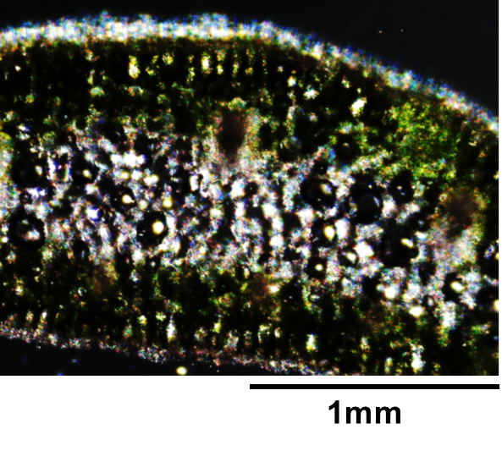
Supplementary Figure S1. A microtome image of the laminar organization of the Chinese chive leaf. The thickness of the slice was around 100 mm and is not exactly same as the OCT in vivo slice images.

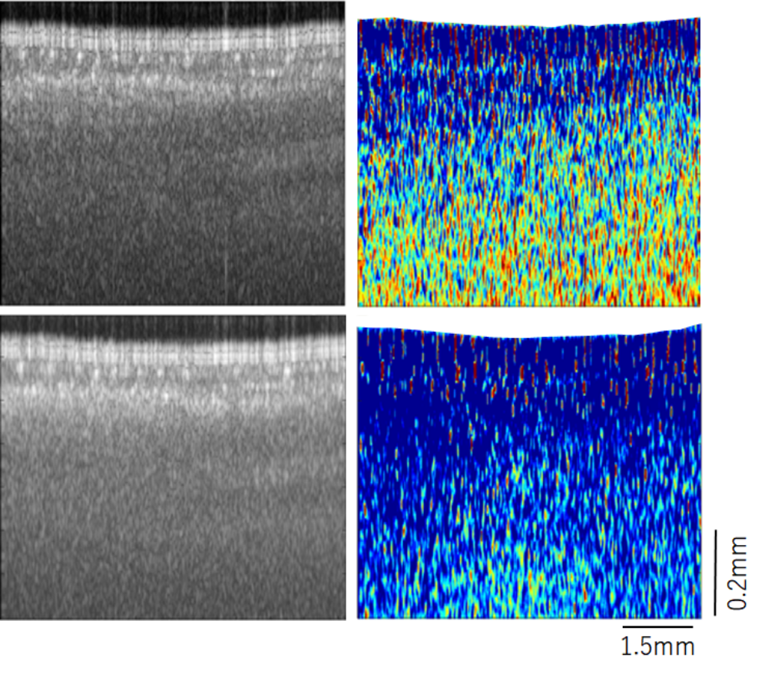
(b)
(c)
(a)
(d)

Supplementary Figure S2. Averaged OCT structural (a,c) and b-OCT speckle contrast (b,d) images obtained before and after 60 min following the foliar application of 100 mM concentration of phytohormone GA₃. Here the averaging is done over six hundred frames. A clear reduction in biospeckle contrast the image could be observed in the bOCT speckle contrast image while in the structural image, the changes are difficult to distinguish.

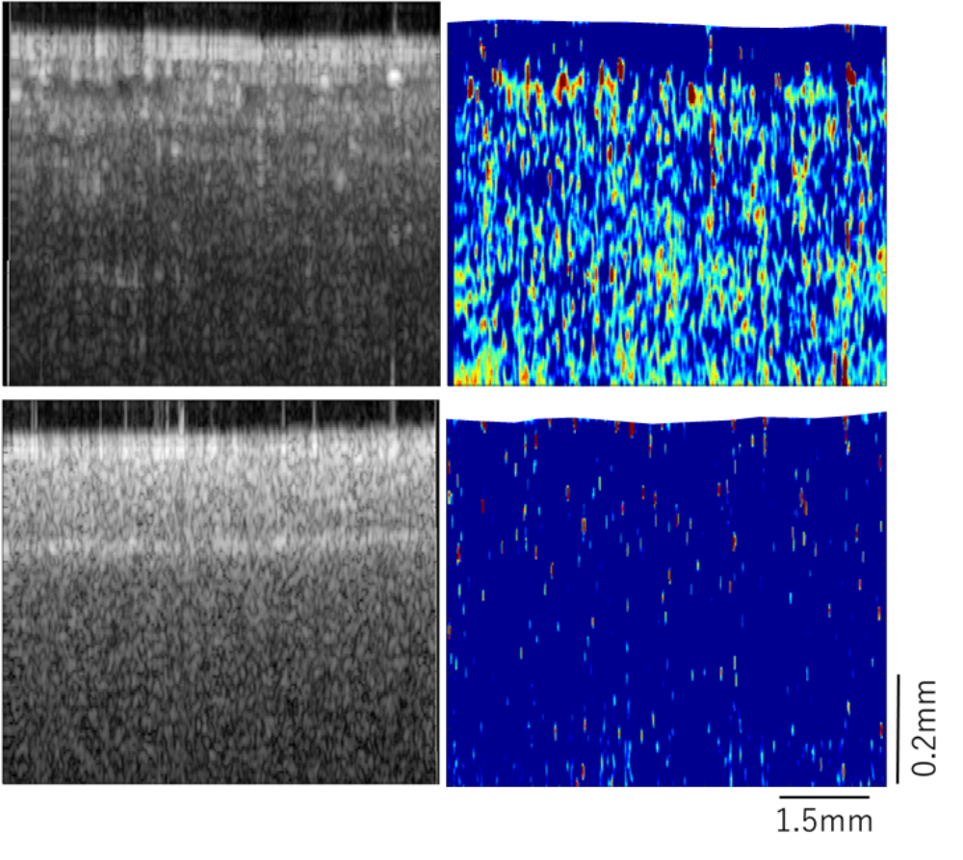
(b)
(d)

(a)
(c)

Supplementary Figure S3. OCT structural (a,c) and b-OCT speckle contrast (b,d) images obtained before and after 120 min following the foliar application of 1200 µM concentration of phytohormone GA₃. The large concentration was used to change in the activity with the application of GA₃ and loss in laminar organization could be observed both in the structural as well as the biospeckle contrast images.

